3a.

The programming language that I used to create my website as HTML, CSS, & Javascript. The purpose of my website was to be part of a bigger website that was going to be used in a previous presentation of innovation for the University of Nebraska at Omaha’s Industrial Technology Innovation Competition. It was going to be used for a user to get assigned a scooter for their use in an attempt to solve the last mile problem of today’s transportation. The video demonstrates a mock user clicking on their location from a dropdown, and the program outputting a scooter near them along with a map of their location. The input of the program is the user selecting their location from a dropdown menu, and the output is a scooter assigned to them along with a map of their location compared to the scooter as the video shows.

3b.

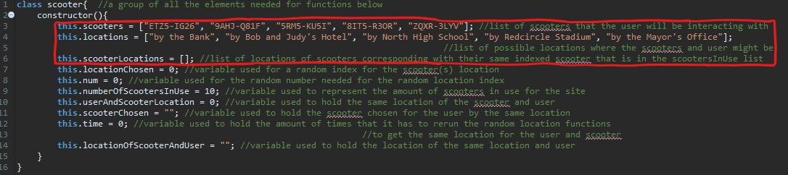

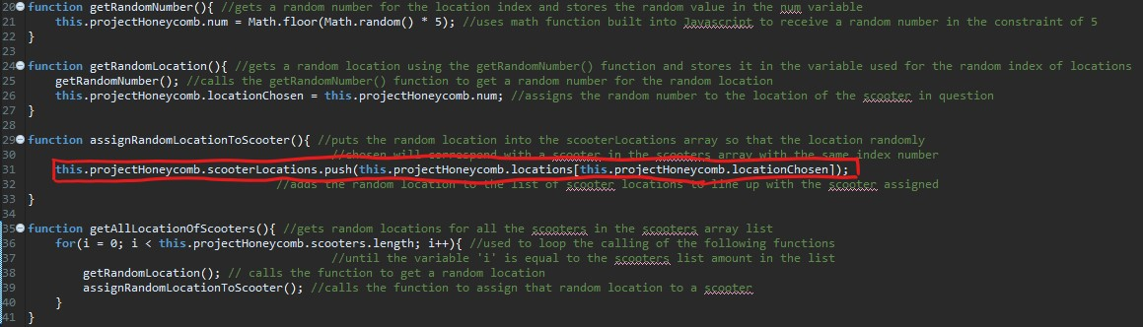

The list shown above is titled scooterLocations. The data that is represented in the list is all the locations that the scooters are located as generated through student wrote algorithms. These algorithms output random numbers that are later used to generate random locations for the scooters. These random locations are then stored in the list as shown in the second code segment. If I did not use the list as shown above in the two code segments, then I would have had to use a lot of it, and, else loops in place of the list. For the list to even exist in the first place, I would have to have several variables that would represent one item in each list. Each variable would have to be either a string or a number which you cannot mix without errors. Once I had these variables initialized then I would have to use if, and, else loops for each variable to check them against the user's input. Furthermore, I would have to create new variables each time I wanted to add a new thing, in addition to the fact that I would have to have new algorithms to view those variables too.

3c.

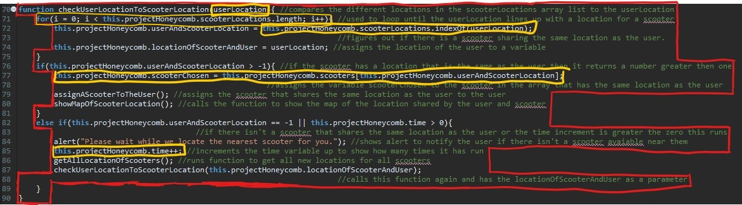

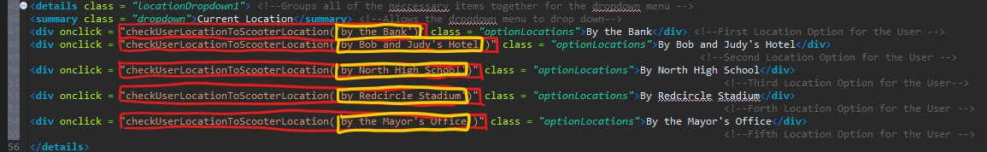

The program above receives the user’s location as an input that will be used to check against the locations of the scooters. This algorithm starts by taking the user’s location as a parameter for the function. It has a loop that repeats until the user’s location lines up with one of the locations of the scooters. Inside the loop, it checks for the user’s location in the list of locations for the scooters. It then saves the user location in a variable for other functions. After the loop completes, there is an if, else loop that checks if the variable returned from comparing the locations is greater than -1. If it is -1 then it outputs a waiting message and reruns the other functions to generate new locations for the scooters. Then it repeats this function all over again to compare the new locations to the user location. If the variable returns greater than -1, the function displays the scooter with the same location, how many scooters are now in use, and a map of the scooter’s location. The whole purpose of this function is to compare the user's location to the scooter's and then output the scooter and map.

3d.

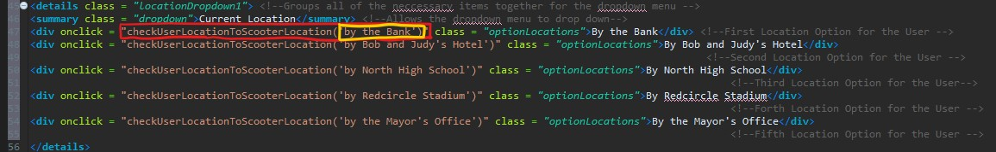

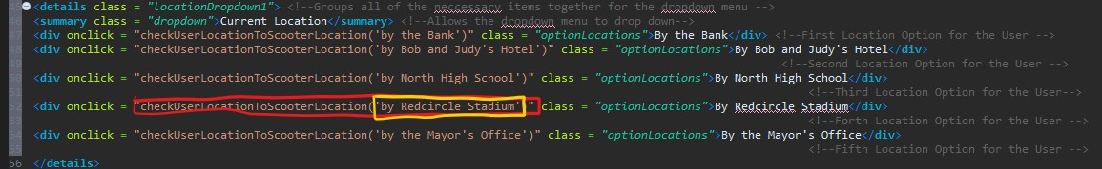

The first call checks the parameter ‘by the Bank’ in its conditions for a scooter shares the same location as the user. If it does, the output of the condition is the scooter with the matching location, map, and increments the number of scooters in use up. If there isn’t a scooter that has the same location as the user, conditions output a message and rerun the functions that are called on the load of the page. The second call checks the parameter ’by Redcircle Stadium’ in the conditionals for a scooter that has the same location as the user. The rest of the calls are interchangeable compared to the first call except for the map and scooter which change as there are different locations. The result of the first call includes the number of scooters being incremented up, the map of ‘by the Bank’ location displayed, and the scooter that has the same location displaying for the user. This occurs if the locations are identical, however, if that is not the case a message displays and the other functions are called. The second call's results are identical except the location changes from 'by the Bank' to 'by Redcircle Stadium'.